Black Widows and Spiders enjoy a Brevard County Reunion
By Chris Bonanno Published 2018 09 28 01:27PM

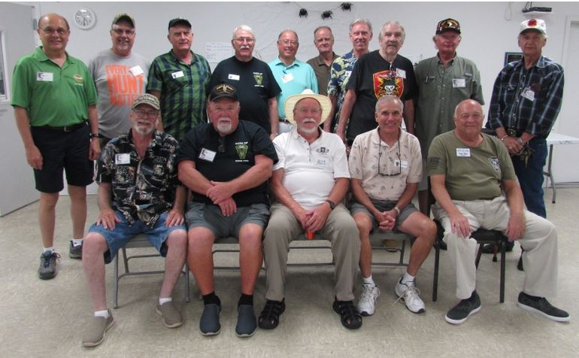
Front Row left to Right – Bill Oates, Lee Lamb, Jesse James, Bill Neubauer, David Miller. Back Row left to right – Al Rasch, Lonnie
Heidtke, Roger Rowles, Ernie Pratt, Terry Bartels, Richard Green, Randy Mains, Doug Cooper, Richard Holland and John Nordentsrom - Photo and article by Senior Life reporter Chris Bonanno.
-------------------------------------------------------------------------------------------------------------------------------------------------------------------------
Proud Vietnam veterans traveled from near and far to Brevard County on Aug. 24 and 25 as the U.S. Army’s 188th Assault Helicopter Company, which is part of the 101st Airborne Division, held a reunion.
As part of the company, members of the groups that were known as the Black Widows and Spiders convened.
“You have no idea how much combat these men have seen,” said David Miller, an original member of the Black Widows.
The Black Widows originally were formed as the 188th in Fort Campbell, Ky. in 1966 as an independent helicopter group, according to Miller. He added that there were three platoons, with two of those being responsible for picking troops up and landing them. The other was a gun platoon that featured gunships. After re-designation as C Company 101st Aviation Battalion, It ended up joining the 101st Division following the Tet Offensive in Vietnam in 1968 when they were moved to the northern part of the country.
The Spider name lives on today with the current unit still responsible today for picking up and landing troops to and from various locations. “They’re very proud of their heritage and we’re very proud of them,” said Miller of troops stationed in Afghanistan bearing the name.
About 50 of the 1400 members of the company (1966-1972) were present on Merritt Island.
The first portion of the weekend reunion was held at the Brevard Veterans Memorial Center on Merritt Island during the afternoon of Aug. 24, in what was more, or less free time for the members of the company and their families to socialize and share stories from the past.
“Just being with each other I guess, being like the old guys,” said Lee Lamb of Palm Bay on what he enjoyed most. Lamb was shot twice on two separate occasions six months apart in Vietnam.
“We’ll never be able to live the old days again, but it feels like the old days. The camaraderie, still after 50-something years, we act like we’re buddies and act like we’re young again.”
“Our museum and our complex is just a perfect place for a reunion and the helicopter at the entrance to our museum has a black widow spider on it. We’re proud of that and I thought it would be a great place to hold the reunion,” added Miller, who also serves on the Center’s board of directors.
The event also featured an Aug. 25 dinner at the International Palms Resort in Cocoa Beach.“This weekend is just an opportunity to get together with the guys I work with all year long,” said Richard A. Green, who served with the group and works with them to produce a newsletter.
Miller noted that the group has been able to stay in touch through the years thanks in large part to social media.
More information can be found about the unit at http://www.vhpa-blackwidows.org/

